Q1 | Create a table called Orders with columns: order_id, user_id, payment_method, and amount. Insert at least 8 sample records representing different users and payment methods (like UPI, Card, Wallet, COD).
Code | Create table ordres:  CREATE TABLE Orders1 ( order_id INT AUTO_INCREMENT, user_id INT, payment_method VARCHAR(20), amount DECIMAL(10,2), PRIMARY KEY(order_id) );  Insert record:  INSERT INTO orders1 VALUES (1, 1, 'UPI', 450), (2, 2, 'Card', 800), (3, 1, 'Wallet', 250), (4, 3, 'COD', 600), (5, 2, 'UPI', 350), (6, 4, 'Card', 1200), (7, 5, 'Wallet', 400), (8, 3, 'COD', 150);  Show table:  SELECT * FROM orders1;
Output | 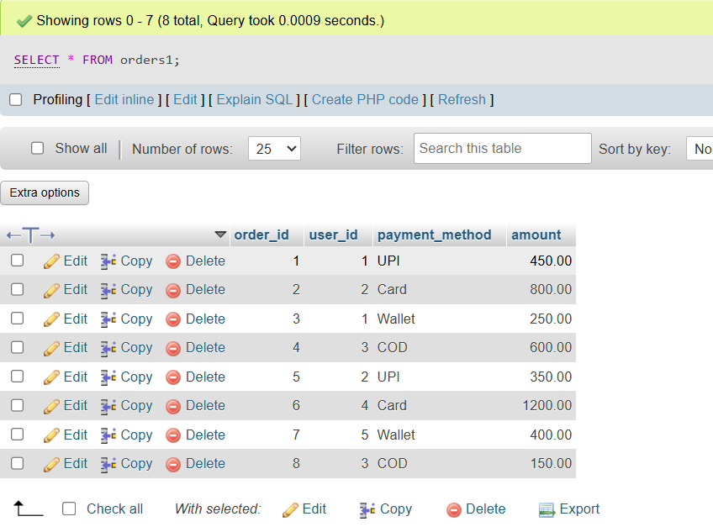

Q2 | Write an SQL query to count how many orders were placed using each payment_method in the Orders table, similar to how Zomato shows payment breakdown in analytics.
Code | SELECT payment_method, COUNT(*) AS total_orders FROM orders1 GROUP BY payment_method;
Output | 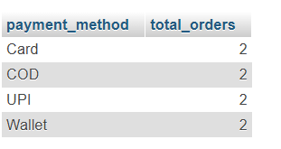

Q3 | Write an SQL query to find the total amount spent by each user_id in the Orders table. Display user_id and their total spend.
Code | SELECT user_id, SUM(amount) AS total_spend FROM Orders1 GROUP BY user_id;
Output | 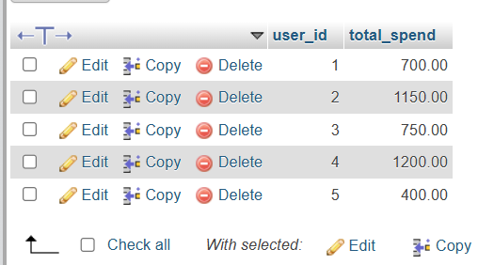

Q4 | Write an SQL query to show only those payment methods where the average order amount is greater than 300, using GROUP BY and HAVING.<br><br><em><strong>Hint:</strong> Use AVG(amount) in your HAVING clause.</em>
Code | SELECT payment_method, AVG(amount) AS average_amount FROM orders1 GROUP BY payment_method HAVING AVG(amount) > 300;
Output | 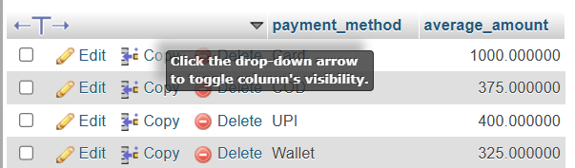

Q5 | Explain the difference between WHERE and HAVING by giving one example query for each, using the Orders table. Your examples should show a scenario where WHERE and HAVING filter different things.
Code | WHERE Example  SELECT * FROM Orders1 WHERE amount > 300;  HAVING Example  SELECT payment_method, SUM(amount) AS total_amount FROM Orders1 GROUP BY payment_method HAVING SUM(amount) > 700;
Output | 